Game Design Document

Fill up the following document

1. Write the title of your project.

Space Invaders

1. What is the goal of the game?

To destroy the enemies without getting killed.

1. Write a brief story of your game.

From a place far far away from your planet Lothal, there are some evils planning to destroy your sweet home… You being the head of a very big space organisation on Lothal, had noticed that there are some unknown ships found at the end of heliosphere…. After doing some research, your team has found out that they are aliens from an other planet Exegol heading towards Lothal to destroy the living life here and then capture the planet… You and your team have to destroy them so that you can save your planet… Are you ready for this ??

1. Which are the playing characters of this game?

* Playing characters are the ones who respond to the user based on the input from the user.
* Cars, monkeys, dinos, wizards, etc., are the playing characters in the game.

|  |  |  |
| --- | --- | --- |
| Number | Character Name | What can this character do? |
| 1 | Ghost | Attack the enemy ship  Move left and right |
| 2 |  |  |
| 3 |  |  |
| 4 |  |  |
| 5 |  |  |
| 6 |  |  |
| 7 |  |  |
| 8 |  |  |

1. Which are the Non-Playing Characters of this game?

* Non-Playing characters are the ones that don't have an action or behavior when the user interacts with the game.
* Hurdles, stones, bananas, coins, etc., are non-playing characters in the game.

|  |  |  |
| --- | --- | --- |
| Number | Character Name | What can this character do? |
| 1 | Star Destroyer | Attack the player’s ship |
| 2 | TIE Fighters | Attack the player’s ship |
| 3 |  |  |
| 4 |  |  |
| 5 |  |  |
| 6 |  |  |
| 7 |  |  |
| 8 |  |  |

Draw your imagination of this game. What does this game look like?

* Draw the game either on your computer or on paper.
* Add images of the game scenes to show each of the playing and non-playing characters at least once.

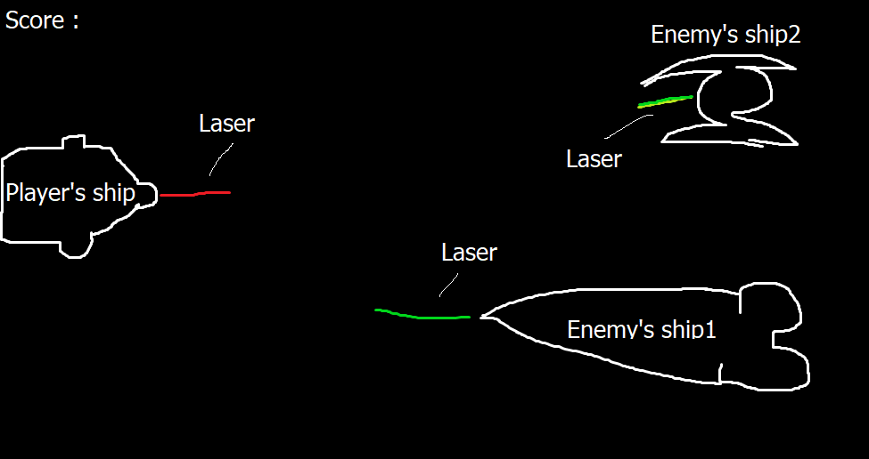

How do you plan to make your game engaging?

When the player destroys certain number of enemy’s ships, the score will get increase by 2.